

**HUM 101: WORLD CIVILIZATIONS AND CULTURES**

Weekly Worksheet #7 (on Session 17 and L18)

Summer 2021

**Part 1**

1. **Multiple Choice:**
2. The Olmecs originated in which of the following areas?
3. North America; (b) Mesoamerica; (c) South America; (d) Iberian Peninsula; (e) None of the above.

**ANS:** (b) Mesoamerica

1. Which of the following kingdom is known as one of the most highly developed common cultures of sub-Saharan Africa:
2. Nubian kingdom; (b) Fatimid Caliphate; (c) Luba; (d)Amhara; (3) Carthaginian Kingdom.

**ANS:** (a) Nubian kingdom

1. The Aztecs were conquered by which European Empire?
2. Frankish Empire; (b) Austro-Hungarian Empire; (c) Spanish Empire; (d) Roman Empire; (e) Danish Empire

**ANS:** (c) Spanish Empire

1. Which of the following items were produced by the Nok people of sub-Saharan Africa?
2. Silk clothes; (b) Battering rams (c)Large palaces; (d) knives and Iron axe; (e) Both a and c.

**ANS:** (d) knives and Iron axe

1. **True/False:**
2. The Bantu people were descendants of the Nubian Kingdom: **FALSE**
3. The Aztecs empire was formed via the “Triple Alliance” and they were also known as the ‘Nahuas’- **TRUE**
4. **Definitions/Identifications (1 or 2 sentences):**
5. Rainforest areas:

**ANS:** A rainforest area is an area of tall, mostly evergreen trees and a high amount of rainfall, has a moisture dependent vegetation with little or no frequency of wildfire.

1. *Ixiptla*:

**ANS:** A Nahua word, has been understood as replacement or substitution and a ritual of human sacrifice in the Aztec Empire.

1. Iron Age:

**ANS:** A prehistoric period that followed the Bronze Age, when weapons and tools came to be made of iron, the final stage of the three-age division.

**Part 2**

1. **Please answer any ONE of the questions in your own words.** (Word Limit 350 to 500 words)
2. Shortly explain the rationale behind the human sacrifice ritual practiced by the Aztecs, and the socio-political impacts of practicing human sacrifice rituals
3. Analyse the greetings given to newborn children in the Aztec culture. Shortly express what does the different greetings for boys and girls reveal about the Aztec culture?
4. Shortly explain how important was the coming of Iron Age behind the Bantu expansion?
5. Select any two locations from the map below where the Bantu speaking people might have concentrated, according to the hypothesis of Malcom Guthrie

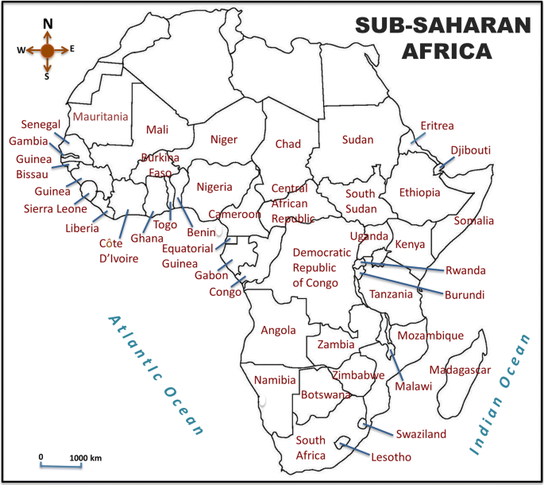

1. **Shortly explain the rationale behind the human sacrifice ritual practiced by the Aztecs, and the socio-political impacts of practicing human sacrifice rituals.**

**ANS:** The Aztec Empire, emerged on 1345 C.E. and fell on 1521 C.E., is best known for being the last of the great Mesoamerican cultures. Before settling in Mesoamerica, they were nomads who moved around central America. They built impressive temple-pyramids, used sophisticated techniques of agriculture and gave birth to many modern entities. The Aztecs believed in many gods and made human sacrifices to their gods. They called it *ixiptlatl*. The process of the sacrifice is stated as like, *the priest would then cut through the abdomen with an obsidian or flint blade. The heart would be torn out still beating and held towards the sky in honor to the Sun-God*. Although this sound very scary, they did it to please their god Huitzilopochtli.

The Aztecs did this human sacrifice because they believed that once a human sacrifice is offered to a god the sacrifice releases immense supernatural energy and the soul of the sacrificed returns to its origin or source and this process frequently takes place. This continuous circulation of the soul returning to its source creates divine energy as they are the containers of the spiritual essence of the deity they embodied.

Nonetheless, the human sacrifice had some political impacts other than religious views. The Aztecs used it as a political tool to show the economic and military power of the Triple Alliance. The man who was sacrificed generally used to be the enslaved people who were taken as a prisoner of war. This gave a message to their potential enemies and vassals about the consequences they might face if they chose to wage war against the Aztecs or the Triple Alliance. They made it clear that they would not be shown any mercy and given a frightful death in the form of human sacrifice towards their god. Once goddess Coyolxhqui tried to oust her step brother Huitzilopochtli and was later beheaded after losing the war against Huitzilopochtli. This was a very popular myth in Aztec cultures who also drove them to recreate this incident by beheading the prisoners of war whose heads rolled down from the top of the pyramid just like Coyolxhqui’s head rolled down from the slopes of Coatepec mountain.

In this manner, Royal rituals were carried out on this temple complex where the military achievements of the Triple alliance were glorified and the message towards the vassals were also sent in order to discourage them from revolting against the Triple Alliance. Finally it can be said that, this practice of ritual sacrifice had a much deeper sense both socially and politically.